Algebra 1: Unit 13, Lesson 5

- The graphs of $y=x^{2}$ and $y={(x-6)}^{2}$ are shown.
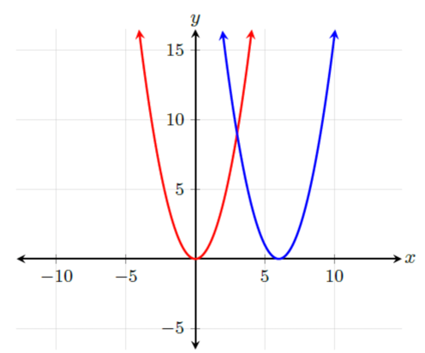
What is the shift from $y=x^{2}$ to $y={(x-6)}^{2}$?
Horizontal shift right 6 units

- A table of values for functions, $f\left(x\right)=x^{3}$ and $g\left(x\right)={(x+3)}^{3}$, is shown.
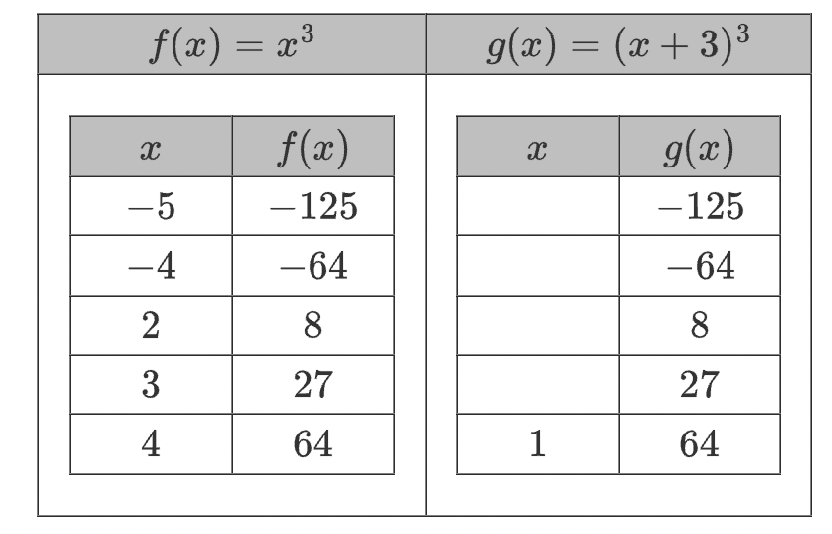
What is the missing $x$-value for the coordinate point when $g\left(x\right)=27$?
( _________, $27$)
0

- A table of values is shown for $y=|x|$ and $y=|x+4|.$
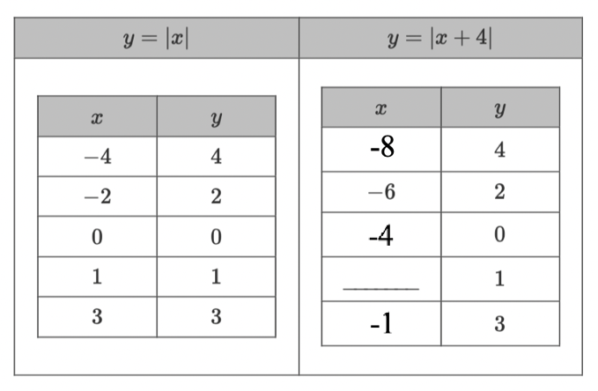
Complete the table of values for $y=|x+4|.$

$$-3$$

